Introduction 2
Minimum requirements 2
Modules 2
Core Container 2
AOP 3
Data Access/Integration 3
Web 3
Test 3
Maven “Bill of Materials” Dependency 3
Spring version comparison 4
List of new features for Spring Framework 3.x 4
List of new features for Spring Framework 4.x 4
The IOC container OR Dependency Injection 5
Introduction to the Spring IOC container and beans 5
Container overview 5
Configuration Metadata 5
Understand Dependency Injection 6
Setup Environment 7
Spring Bean Factory 7
Setter Injection 8
Constructor Injection 8
Inner Beans, Aliases and idref 8
Initializing Collections 9
Bean Autowiring 10
Bean Scope 11
Method Injection Using ApplicationContextAware 12
Bean definition inheritance 13
How to load multiple Spring bean configuration file 14
Bean Lifecycle call-backs, BeanPostProcessor, BeanFactoryPostProcessor 14
Best practices writing Spring Configuration 15
Annotation based configuration 16
Auto Component Scanning & Stereotypes 18
Filter component – include 18
Filter component – exclude 19
Stereotypes- 19
Resource Handling 19
Resource Loader 19

Introduction
Spring framework was initially written by Rod Johnson and was first released under the Apache 2.0 license in June 2003.

Spring is
- Open source framework
- Container of beans which manage life cycle of beans more or less same as Tomcat is container of servlets
- Based on layered architecture, which allows you to be selective about which of its components you use while also providing a consistent framework for J2EE application development.

Minimum requirements
- JDK 6+ for Spring Framework 4.x
- JDK 5+ for Spring Framework 3.x

Modules
The Spring Framework consists of features organized into about 20 modules. These modules are grouped into Core Container, Data Access/Integration, Web, AOP (Aspect Oriented Programming), Instrumentation, Messaging, and Test, as shown in the following diagram.

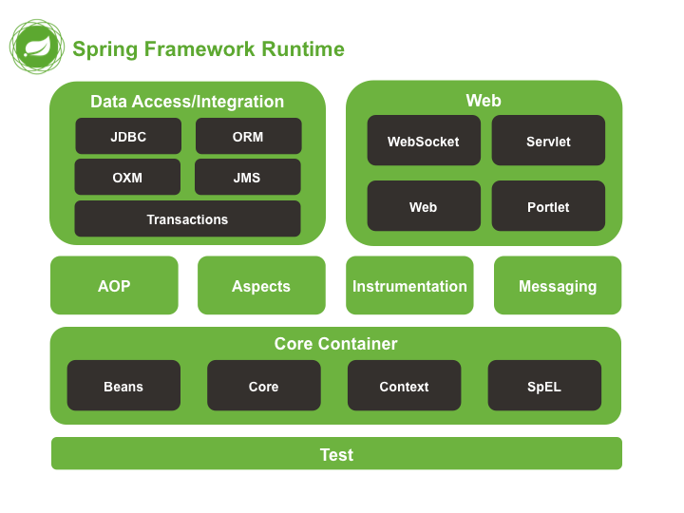

Core Container
- It consists of the spring-core, spring-beans, spring-context, spring-context-support, and spring-expression (Spring Expression Language) modules.
- Spring-core & spring-beans provides fundamental part of framework, including IoC & Dependency Injection feature
- The spring-context module adds support for internationalization.
- The spring-context-support provides support for integrating common third-party libraries into a Spring application context for caching (EhCache, Guava, JCache), mailing (JavaMail), scheduling (CommonJ, Quartz) and template engines (FreeMarker, JasperReports, Velocity).

AOP
- The spring-aop module provides features like method interceptors and pointcuts to cleanly decouple code that implements functionality that should be separated.
- The spring-aspects module provides integration with AspectJ.

Data Access/Integration
- The spring-jdbc module provides a JDBC-abstraction layer that removes the need to do tedious JDBC coding and parsing of database-vendor specific error codes.
- The spring-tx module supports programmatic and declarative transaction management
- The spring-orm module provides integration layers for popular object-relational mapping APIs, including JPA, JDO, and Hibernate.

Web
- The spring-web module provides basic web-oriented integration features such as multipart file upload functionality and the initialization of the IoC container using Servlet listeners and a web-oriented application context. It also contains an HTTP client.
- The spring-webmvc module (also known as the Web-Servlet module) contains Spring’s model-view-controller (MVC) and REST Web Services implementation for web applications.

Test
The spring-test module supports the unit testing and integration testing of Spring components with JUnit or TestNG. It provides consistent loading of Spring ApplicationContexts and caching of those contexts. It also provides mock objects that you can use to test your code in isolation.

Maven “Bill of Materials” Dependency

To use the Spring Maven repository, you need to specify the repository location in your Maven configuration (setting.xml)
<repositories>
<repository>
<id>io.spring.repo.maven.release</id>
<url>http://repo.spring.io/release/</url>
<snapshots>
<enabled>false</enabled>
</snapshots>
</repository>
</repositories>

It is possible to accidentally mix different versions of Spring JARs when using Maven. For example, you may find that a third-party library, or another Spring project, pulls in a transitive dependency to an older release. If you forget to explicitly declare a direct dependency yourself, all sorts of unexpected issues can arise.
To overcome such problems Maven supports the concept of a "bill of materials" (BOM) dependency. You can import the spring-framework-bom in your dependency Management section to ensure that all spring dependencies (both direct and transitive) are at the same version.
<dependencyManagement>
<dependencies>
<dependency>
<groupId>org.springframework</groupId>
<artifactId>spring-framework-bom</artifactId>
<version>4.1.6.RELEASE</version>
<type>pom</type>
<scope>import</scope>
</dependency>
</dependencies>
</dependencyManagement>

An added benefit of using the BOM is that you no longer need to specify the <version> attribute when depending on Spring Framework artifacts:
<dependencies>
<dependency>
<groupId>org.springframework</groupId>
<artifactId>spring-context</artifactId>
</dependency>
<dependency>
<groupId>org.springframework</groupId>
<artifactId>spring-web</artifactId>
</dependency>
<dependencies>

Spring version comparison
Spring 2.0 provided XML namespaces and AspectJ support; Spring 2.5 embraced annotation-driven configuration; Spring 3.0 introduced a strong Java 5+ foundations across the framework codebase, and features such as the Java-based @Configuration model.
Version 4.0 is the latest major release of the Spring Framework and the first to fully support Java 8 features. You can still use Spring with older versions of Java, however, the minimum requirement has now been raised to Java SE 6

List of new features for Spring Framework 3.x
- Fully Java 5 based
- Spring Expression Language
- Extended support for annotation-based components
- Comprehensive REST support
- Object/XML Mapping (OXM): as known from Spring Web Services, now in Spring Framework core.
- Portlet 2.0 support: Spring MVC fully supports Portlet 2.0 environments and Portlet 2.0’s new event and resource request model.
- Next-generation scheduling capabilities: new TaskScheduler and Trigger mechanisms with first-class cron support, aligned with Spring’s TaskExecutor mechanism.
- Early support for Java EE 6 - We provide support for asynchronous method invocations through the use of the new @Async annotation
- Embedded database support - including HSQL, H2, and Derby, is now provided

List of new features for Spring Framework 4.x
- Fully support Java 8 features
- JMS Improvement
- Caching Improvement
- Web Improvement like JSON support as a Response body

The IOC container OR Dependency Injection

Introduction to the Spring IOC container and beans
IOC is also known as dependency injection (DI). It is a process whereby objects define their dependencies, that is, the other objects they work with, only through constructor arguments, arguments to a factory method, or properties that are set on the object instance after it is constructed or returned from a factory method. The container then injects those dependencies when it creates the bean. This process is fundamentally the inverse, hence the name Inversion of Control (IoC).

The org.springframework.beans and org.springframework.context packages are the basis for Spring Framework's IoC container.

In spring, the objects that form the backbone of your application and that are managed by the Spring IoC container are called beans. A bean is an object that is instantiated, assembled, and otherwise managed by a Spring IoC container.

BeanFactory interface provides an advanced configuration mechanism capable of managing any type of object.
ApplicationContext interface is a sub interface of BeanFactory. It adds easier integration with spring’s AOP features; message resource handling (for use in internationalization), event publication; and application-layer specific contexts such as the WebApplicationContext for use in web applications.

Several implementations of the ApplicationContext interface are supplied out-of-the box with spring. In standalone applications it is common to create an instance of ClassPathXmlApplicationContext or FileSystemXmlApplicationContext.

Container overview
The interface org.springframework.context.ApplicationContext represents the Spring IOC Container.
The container gets its instructions on what objects to instantiate, configure, and assemble by reading configuration metadata.

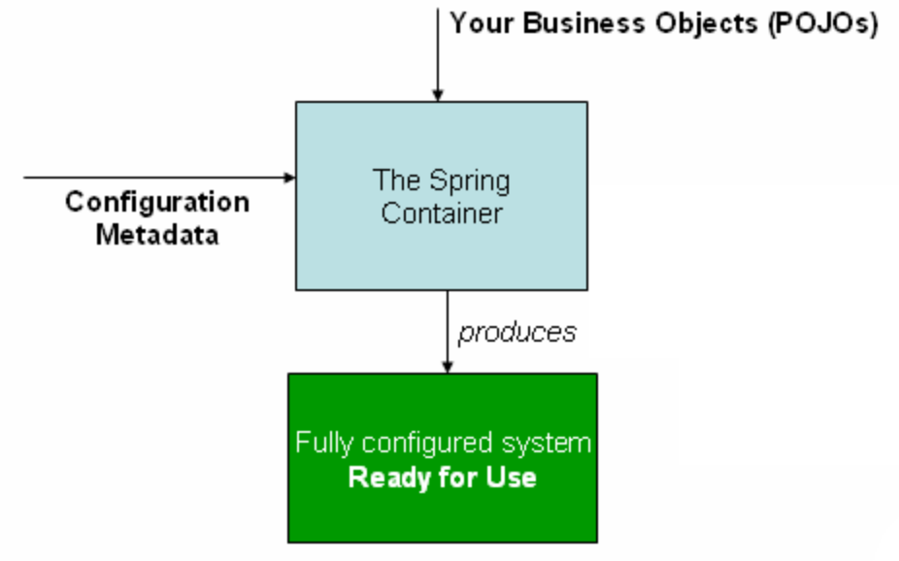

Configuration Metadata
The configuration metadata is represented in XML, Java annotations, or Java code.
The configuration metadata represents how you as an application developer tell the Spring container to instantiate, configure, and assemble the objects in your application.

- XML based configuration
Basic structure of XML-based configuration metadata:
<?xml version="1.0" encoding="UTF-8"?>
<beans xmlns="http://www.springframework.org/schema/beans"xmlns:xsi="http://www.w3.org/2001/XMLSchema-instance"
xsi:schemaLocation="http://www.springframework.org/schema/beans
http://www.springframework.org/schema/beans/spring-beans.xsd">
<bean id="..." class="...">
<!-- collaborators and configuration for this bean go here -->
</bean>
<bean id="..." class="...">
<!-- collaborators and configuration for this bean go here -->
</bean>
<!-- more bean definitions go here -->
</beans>
The id attribute is a string that you use to identify the individual bean definition. The class attribute defines the type of the bean and uses the fully qualified classname. The value of the id attribute refers to collaborating objects.

Instantiating a container
ApplicationContext context =
new ClassPathXmlApplicationContext(new String[] {"services.xml", "daos.xml"});

- Annotation based configuration
Spring 2.5 introduced support for annotation-based configuration metadata
- Java-based configuration
Starting with Spring 3.0, many features provided by the Spring JavaConfig project became part
of the core Spring Framework
Instantiating the Spring container using AnnotationConfigApplicationContext.
Java-configuration support are @Configuration-annotated classes and @Bean-annotated
methods.

Understand Dependency Injection
Main idea of DI is to decouple all dependent object so that they are not tight to each other as well as every object should be easily unit testable.

For Example-
Step1
In below example, SmsSenderApplication is depending on GSM & CDMA object.
class GSM {
Void sendSMS(){}
}

class CDMA {
Void sendSMS(){}
}

class SmsSenderApplication {
Void sendSMS() {
If(type == 1) {
GSM gsm = new GSM();
gsm.sendSMS();
} else {
CDMA cdma = new CDMA();
cdma.sendSMS();
}
}
}

Step2
Remove GSM & CDMA dependencies from SmsSenderApplication by using Polymorphism
interface Device {
Void sendSMS();
}

class GSM implements Device {
Void sendSMS(){}
}

class CDMA implements Device {
Void sendSMS(){}
}

class SmsSenderApplication {
private Device device;
Void sendSMS() {
this.device.sendSMS();
}
// injecting dependencies via setter
Void setDevice(Device device) {
this.device = device;
}
}

So, in nutshell DI are –
We are removing dependent Object (like GSM & CDMA) from SmsSenderApplication & injecting these dependencies via Spring Container (above example is related to setter injection).
Program more towards interface instead of Concrete classes to make code easily maintainable & testable.

Setup Environment
- Create a Maven project “Spring-IOC”

- Add BOM dependencies
<!-- BOM Dependencies -->
<dependencyManagement>
<dependencies>
<dependency>
<groupId>org.springframework</groupId>
<artifactId>spring-framework-bom</artifactId>
<version>4.1.6.RELEASE</version>
<type>pom</type>
<scope>import</scope>
</dependency>
</dependencies>
</dependencyManagement>

- Add spring Core & context dependencies

- mvn clean install –U
mvn eclipse:eclipse and finally refresh eclipse project

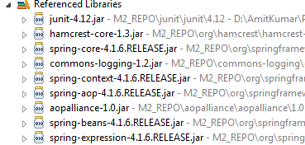

Spring Bean Factory
Spring manages bean creation based on factory design pattern. Spring Bean factory is based on factory design pattern.

Bean Factory is responsible to create instance of beans OR resolve dependencies via configuration metadata (XML / annotation).

Factory design pattern
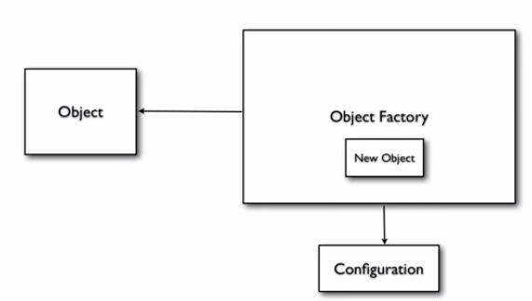

Spring Bean Factory
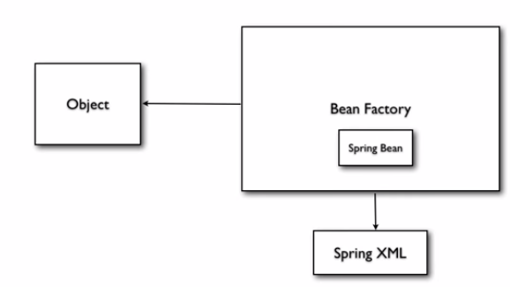

Setter Injection
This example is based on setter injection mechanism. A very simple way to declare Metadata using XML & access bean based on Bean factory pattern using Bean Factory OR Application Context interface anywhere in the application.

The id attribute is a string that you use to identify the individual bean definition. The class attribute defines the type of the bean and uses the fully qualified classname. The value of the id attribute refers to collaborating objects. Property tag use setter to inject value.

The p-namespace enables you to use the bean element’s attributes, instead of nested <property/> elements, to describe your property values and/or collaborating beans.

Example: com.gps.spring.ioc.pojo.HelloWorld.java, HelloWorldConfig.xml, com.gps.spring.ioc.client.HelloWorldClient.java

Constructor Injection
- Using index, value & type attributes
- Auto convert data type
- UnsatisfiedDependencyException – If Ambiguous constructor argument found OR matching constructor not found inside Metadata configuration
- BeanDefinitionParsingException – If Id will be same inside Metadata configuration
- NoSuchBeanDefinitionException – If request bean not found inside Metadata configuration
- Ref attribute is used to refer another bean Id (i.e. to inject other Object).
- Example: com.gps.spring.ioc.pojo.Employee.java, EmployeeConfig.xml, com.gps.spring.ioc.client.EmployeeClient.java

Inner Beans, Aliases and idref
- Inner Bean- Whenever we need to use a bean inside another bean only then don’t need to define bean with Id as well as define it inside enclosing bean. For example- In one of the application Address bean only be required inside Employee. There would not be individual existence of Address bean separately. Defining id is not required inside inner bean.
Example: com.gps.spring.ioc.pojo.Employee.java, EmployeeConfig.xml, com.gps.spring.ioc.client.EmployeeClient.java
- Aliases- We can provide different name for the same bean.
Question – What is difference between bean Id & name attribute of bean tag?
Example: com.gps.spring.ioc.pojo.HelloWorld.java, BeanPropertiesConfig.xml, com.gps.spring.ioc.client.BeanIdAndNameComparator.java
IdRef- The idref element is simply an error-proof way to pass the id (string value - not a reference) of another bean in the container to a <constructor-arg/> or<property/> element.
<bean id="theTargetBean" class="..."/>

<bean id="theClientBean" class="...">
<property name="targetName">
<idref bean="theTargetBean" />
</property>
</bean>
The above bean definition snippet is exactly equivalent (at runtime) to the following snippet:
<bean id="theTargetBean" class="..." />

<bean id="client" class="...">
<property name="targetName" value="theTargetBean" />
</bean>

A common place (at least in versions earlier than Spring 2.0) where the <idref/> element brings value is in the configuration of AOP interceptors in a ProxyFactoryBean bean definition. Using <idref/> elements when you specify the interceptor names prevents you from misspelling an interceptor id.

Question – What is difference between bean Id & IdRef?
Example: com.gps.spring.ioc.pojo.Employee.java, EmployeeConfig.xml, com.gps.spring.ioc.client.EmployeeClient.java

Initializing Collections
- List
Example: com.gps.spring.ioc.pojo.Employee.java, com.gps.spring.ioc.dao.EmployeeDAO.java EmployeeConfig.xml, com.gps.spring.ioc.client.EmployeeServiceClient.java

- Map
<property name="someMap">
<map>
<entry key="an entry" value="just some string"/>
<entry key ="a ref" value-ref="myDataSource"/>
</map>
</property>

- Set
<property name="someSet">
<set>
<value>just some string</value>
<ref bean="myDataSource" />
</set>
</property>

- Properties
<property name="adminEmails">
<props>
<prop key="administrator">administrator@example.org</prop>
<prop key="support">support@example.org</prop>
<prop key="development">development@example.org</prop>
</props>
</property>

- Merging collections
<beans>
<bean id="parent" abstract="true" class="example.ComplexObject">
<property name="adminEmails">
<props>
<prop key="administrator">administrator@example.com</prop>
<prop key="support">support@example.com</prop>
</props>
</property>
</bean>
<bean id="child" parent="parent">
<property name="adminEmails">
<!-- the merge is specified on the child collection definition -->
<props merge="true">
<prop key="sales">sales@example.com</prop>
<prop key="support">support@example.co.uk</prop>
</props>
</property>
</bean>
<beans>
Notice the use of the merge=true attribute on the <props/> element of the adminEmails property of the child bean definition. When the child bean is resolved and instantiated by the container, the resulting instance has an adminEmails Properties collection that contains the result of the merging of the child’s adminEmails collection with the parent’s adminEmails collection.
administrator=administrator@example.com
sales=sales@example.com
support=support@example.co.uk
You cannot merge different collection types (such as a Map and a List), and if you do attempt to do so an appropriate Exception is thrown.
- Null & Empty string value
<bean class="ExampleBean">
<property name="email">
<null/>
</property>
</bean>

<bean class="ExampleBean">
<property name="email" value=""/>
</bean>

Bean Autowiring
By Default autowire is off means no Autowiring.
Autowiring reduces some of the configuration intelligently by Spring itself inside Metadata configuration.

The Spring container can autowire relationships between collaborating beans. You can allow Spring to resolve collaborators (other beans) automatically for your bean by inspecting the contents of the ApplicationContext. Autowiring has the following advantages:
- Autowiring can significantly reduce the need to specify properties or constructor arguments.
- Autowiring can update a configuration as your objects evolve. For example, if you need to add a dependency to a class, that dependency can be satisfied automatically without you needing to modify the configuration.

Asked Spring to autowire beans based on
- By Name: To resolve dependencies, Spring checks each of member variables of bean with same name defined inside configuration XML file.

- By Type: It works if we have only one member variable & only one bean of each type. If class of bean matches with the class of member variable defined then only autowire this bean. If more than one exists, a fatal exception is thrown, which indicates that you may not use byType Autowiring for that bean. If there are no matching beans, nothing happens; the property is not set.

- By Constructor: It works same as the type but instead of setter injection it looks for constructor injection. Analogous to byType, but applies to constructor arguments. If there is not exactly one bean of the constructor argument type in the container, a fatal error is raised.

Example: com.gps.spring.ioc.pojo.Connection.java, com.gps.spring.ioc.dao.DAOManagerFactory.java, AutoWiredConfig.xml, com.gps.spring.ioc.client.DAOManagerServiceClient.java

Bean Scope
There are 2 basic bean scopes in spring – Singleton & Prototype

Singleton
Default scope of bean. Initialize bean only once per Spring container. Initialization occurs during container initialized.
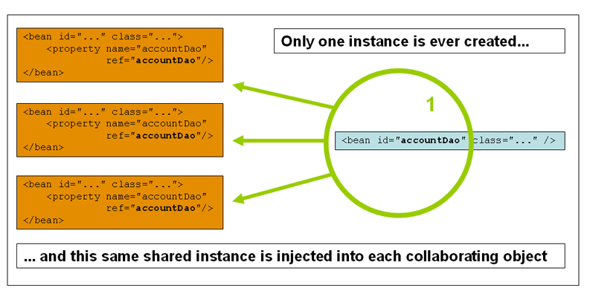

Prototype
New bean object created with every request / reference. Whenever we call getBean() then new instance of bean will be initialized.
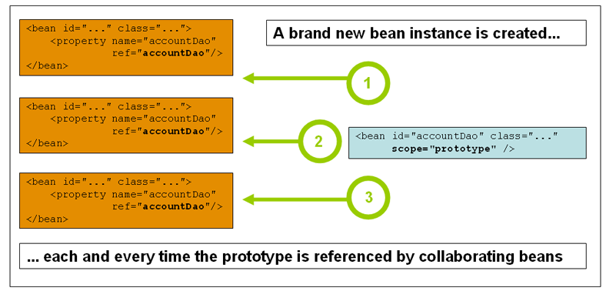

Web-aware Context Bean scopes
- Request – New bean per servlet request
- Session – New bean per session
- Global Session – Applicable in Portlet context. New bean per global Http Session (per Portlet context)
- Application - Scopes a single bean definition to the lifecycle of a ServletContext. Only valid in the context of a web-aware Spring ApplicationContext.

Example: com.gps.spring.ioc.pojo.HelloWorld.java, BeanScopeConfig.xml, com.gps.spring.ioc.client.SingletonScopeExample.java, com.gps.spring.ioc.client.PrototypeScopeExample.java

Lazy loading OR Pre-Loading
Bean factory always load all singleton bean using Lazy loading whereas application context always do pre-load. For application context, we can do lazy loading using lazy-init=”true” for any singleton scope bean.

Method Injection Using ApplicationContextAware
In most application scenarios, most beans in the container are singletons. When a singleton bean needs to collaborate with another singleton bean, or a non-singleton bean needs to collaborate with another non-singleton bean, you typically handle the dependency by defining one bean as a property of the other.

Problem - A problem arises when the bean lifecycles are different. Suppose singleton bean A needs to use non-singleton (prototype) bean B, perhaps on each method invocation on A. The container only creates the singleton bean A once, and thus only gets one opportunity to set the properties. The container cannot provide bean A with a new instance of bean B every time one is needed.
Solution - You can make bean A aware of the container by implementing the ApplicationContextAware interface (ApplicationContext should scan for ApplicationContextAware beans and invoke setApplicationContext by passing an implementation of its instance), and by making a getBean("B") call to the container ask for (a typically new) bean B instance every time bean A needs it.

Use case - This interface can also be implemented if an object needs access to file resources, i.e. wants to call getResource, wants to publish an application event, or requires access to the MessageSource.
However, it is preferable to implement the more specific ResourceLoaderAware, ApplicationEventPublisherAware or MessageSourceAware
interface in such a specific scenario.
Example: com.gps.spring.ioc.pojo.SimpleBean.java, app-aware-context.xml, com.gps.spring.ioc.dao.SimpleBeanFactory.java, com.gps.spring.ioc.client.ApplicationContextAwareClient.java

Bean scope using annotation
@Scope("prototype")
public class CustomerService
{
String message;

public String getMessage() {
return message;
}

public void setMessage(String message) {
this.message = message;
}
}
Enable auto component scanning:
<beans xmlns="http://www.springframework.org/schema/beans"
xmlns:xsi="http://www.w3.org/2001/XMLSchema-instance"
xmlns:context="http://www.springframework.org/schema/context"
xsi:schemaLocation="http://www.springframework.org/schema/beans
http://www.springframework.org/schema/beans/spring-beans-2.5.xsd
http://www.springframework.org/schema/context
http://www.springframework.org/schema/context/spring-context-2.5.xsd">

<context:component-scan base-package="com.gps.spring.ioc.pojo" />

</beans>

Bean definition inheritance
In Spring, the inheritance is supported in bean configuration for a bean to share common values, properties or configurations.

A bean definition can contain a lot of configuration information, including constructor arguments, property values, and container-specific information such as initialization method, static factory method name, and so on. A child bean definition inherits configuration data from a parent definition. The child definition can override some values, or add others, as needed. Using parent and child bean definitions can save a lot of typing. Effectively, this is a form of templating.

Example1-
<bean id="inheritedTestBean" abstract="true"
class="org.springframework.beans.TestBean">
<property name="name" value="parent"/>
<property name="age" value="1"/>
</bean>

<bean id="inheritsWithDifferentClass"
class="org.springframework.beans.DerivedTestBean"
parent="inheritedTestBean" init-method="initialize">
<property name="name" value="override"/>
<!-- the age property value of 1 will be inherited from parent -->
</bean>

Example2-
<bean id="inheritedTestBeanWithoutClass" abstract="true">
<property name="name" value="parent"/>
<property name="age" value="1"/>
</bean>

<bean id="inheritsWithClass" class="org.springframework.beans.DerivedTestBean"
parent="inheritedTestBeanWithoutClass" init-method="initialize">
<property name="name" value="override"/>
<!-- age will inherit the value of 1 from the parent bean definition-->
</bean>

Example: com.gps.spring.ioc.pojo.Customer.java, bean-inheritence-context.xml, com.gps.spring.ioc.client.BeanDefinitionClient.java

How to load multiple Spring bean configuration file
In a large project structure, the Spring’s bean configuration files are located in different folders for easy maintainability and modular. For example, Spring-Common.xml in common folder, Spring-Connection.xml in connection folder, Spring-ModuleA.xml in ModuleA folder…and etc.

Put all spring xml files under project classpath-
project-classpath/Spring-Common.xml
project-classpath/Spring-Connection.xml
project-classpath/Spring-ModuleA.xml

We can load multiple Spring bean configuration files in the code-
ApplicationContext context =
new ClassPathXmlApplicationContext(new String[] {"Spring-Common.xml",
"Spring-Connection.xml","Spring-ModuleA.xml"});

Better solution is:
The above ways are lack of organizing and error prone, the better way should be organized all your Spring bean configuration files into a single XML file. For example, create a Spring-All-Module.xml file, and import the entire Spring bean files like this:

<beans xmlns="http://www.springframework.org/schema/beans"
xmlns:xsi="http://www.w3.org/2001/XMLSchema-instance"
xsi:schemaLocation="http://www.springframework.org/schema/beans
http://www.springframework.org/schema/beans/spring-beans-2.5.xsd">

<import resource="common/Spring-Common.xml"/>
<import resource="connection/Spring-Connection.xml"/>
<import resource="moduleA/Spring-ModuleA.xml"/>

</beans>

Put this file under project classpath-
project-classpath/Spring-All-Module.xml

Now you can load a single xml file like this-
ApplicationContext context =
new ClassPathXmlApplicationContext(Spring-All-Module.xml);

Bean Lifecycle call-backs, BeanPostProcessor, BeanFactoryPostProcessor
Spring framework provides following 4 ways for controlling life cycle events of bean-
- InitializingBean and DisposableBean callback interfaces
- Other Aware interfaces for specific behavior
- custom init() and destroy() methods in bean configuration file
- @PostConstruct and @PreDestroy annotations

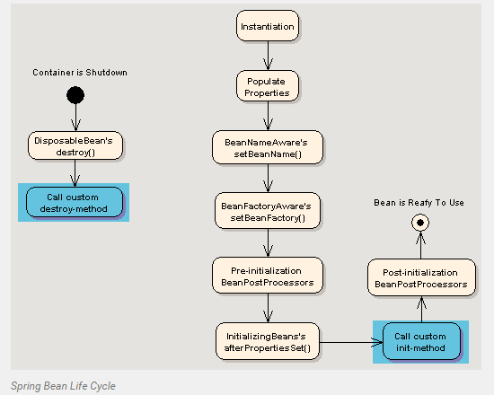

InitializingBean (@PostConstruct) – The container calls afterPropertiesSet() to allow the bean to perform certain actions upon initialization of your beans.
OR
To call custom method to initialize bean. Advantage is – Application code is not depend on spring codebase classes or interfaces.
<bean id="exampleInitBean" class="examples.ExampleBean" init-method="init"/>

DisposableBean (@PreDestroy) - The container calls destroy() to allow the bean to perform certain actions upon destruction of your beans
OR
To call custom method for clean operation
<bean id="exampleInitBean" class="examples.ExampleBean" destroy-method="cleanup"/>

Example: com.gps.spring.ioc.pojo.LifeCycleBean.java, com.gps.spring.ioc.pojo.MyBeanInitProcessor.java, spring-lifecycle-context.xml, com.gps.spring.ioc.client.BeanLifcycleClient.java, com.gps.spring.ioc.client.MyBeanFactoryPostProcessor.java

Question: How to externalize bean properties via property file?
Use org.springframework.beans.factory.config.PropertyPlaceholderConfigurer

Best practices writing Spring Configuration
- Add header comment to each configuration file
<beans>
<description>
This configuration file will have all beans
which may be used for controlling transactions.
</description>
...
</beans>

- Prefer setter injection over constructor injection

- Prefer to use TYPE over INDEX for constructor argument matching in constructor injection

- Use shortcut for instead of expanded form

<!-- Expanded version -->
<bean id="employeeDAO" class="com.howtodoinjava.dao.EmployeeDAO">
<property name="datasource">
<ref bean="datasource"></ref>
<value>datasource</value>
</property>
</bean>

<!-- Shorter/shortcut version -->
<bean id="employeeDAO" class="com.howtodoinjava.dao.EmployeeDAO">
<property name="datasource" ref="datasource" value="datasource">
</bean>

- Reuse bean definition as much as possible
<bean id="abstractDataSource" class="org.apache.commons.dbcp.BasicDataSource"
destroy-method="close"
p:driverClassName="${jdbc.driverClassName}"
p:username="${jdbc.username}"
p:password="${jdbc.password}" />

<bean id="concreteDataSourceOne"
parent="abstractDataSource"
p:url="${jdbc.databaseurlOne}"/>

<bean id="concreteDataSourceTwo"
parent="abstractDataSource"
p:url="${jdbc.databaseurlTwo}"/>

- Always use Ids as bean identifier

- Try to avoid Autowiring
As soon as project gets bigger, Autowiring starts creating trouble in identifying correct dependency to use.

- Always use classpath prefix

- Always externalize properties

- Always prefer to code using interface instead of Classes

Annotation based configuration
Starting from Spring 2.5 it became possible to configure the dependency injection using annotations. So instead of using XML to describe a bean wiring, you can move the bean configuration into the component class itself by using annotations on the relevant class, method, or field declaration.

Annotation wiring is not turned on in the Spring container by default. So, before we can use annotation-based wiring, we will need to enable it in our Spring configuration file. So consider to have following configuration file in case we want to use any annotation in our Spring application. Internally, this will define all bean post processors.

<?xml version="1.0" encoding="UTF-8"?>
<beans xmlns="http://www.springframework.org/schema/beans"
xmlns:xsi="http://www.w3.org/2001/XMLSchema-instance"
xmlns:context="http://www.springframework.org/schema/context"
xsi:schemaLocation="http://www.springframework.org/schema/beans
http://www.springframework.org/schema/beans/spring-beans-3.0.xsd
http://www.springframework.org/schema/context
http://www.springframework.org/schema/context/spring-context-3.0.xsd">
<context:annotation-config/>
<!-- bean definitions go here -->
- @Required - The @Required annotation applies to bean property setter methods and it indicates that the affected bean property must be populated in XML configuration file at configuration time otherwise the container throws a BeanInitializationException exception.

- @Autowired – When Spring finds an @Autowired annotation used with setter methods, it tries to perform byType Autowiring on the method. If it find multiple beans then look for byname.

We can apply @Autowired to constructors as well. A constructor @Autowired annotation indicates that the constructor should be Autowired when creating the bean, even if no <constructor-arg> elements are used while configuring the bean in XML file.

- @Qualifier - There may be a situation when you create more than one bean of the same type and want to wire only one of them with a property, in such case you can use @Qualifier annotation along with @Autowired to remove the confusion by specifying which exact bean will be wired.

- @PostConstruct (JSR-250 based annotations : javax.annotation) – We can use @PostConstruct annotation as an alternate of initialization call-back

- @PreDestroy (JSR-250 based annotations : javax.annotation) – We can use @PreDestroy annotation as an alternate of destruction call-back

- @Resource (JSR-250 based annotations: javax.annotation) – You can use @Resource annotation on fields or setter methods and it works the same as in Java EE 5. The @Resource annotation takes a 'name' attribute which will be interpreted as the bean name to be injected. We can say it follows by-name Autowiring. If no 'name' is specified explicitly, the default name is derived from the field name.

Example: com.gps.spring.ioc.annotation.pojo.Address.java, com.gps.spring.ioc.annotation.pojo.Employee.java, com.gps.spring.ioc.annotation.pojo.GPSEmployee.java
com.gps.spring.ioc.annotation.pojo.GPSResourceEmployee.java com.gps.spring.ioc.annotation.client.EmployeeClient.java, annotation\EmployeeConfig.xml

- @Scope(“singleton”)

- @Configuration & @Bean - Since Spring 3, JavaConfig features are included in core Spring module, it allow developer to move bean definition and Spring configuration out of XML file into Java class.
The @Bean annotation is used to indicate that a method instantiates, configures and initializes a new object to be managed by the Spring IoC container.
Spring XML file :
<beans xmlns="http://www.springframework.org/schema/beans"
xmlns:xsi="http://www.w3.org/2001/XMLSchema-instance"
xsi:schemaLocation="http://www.springframework.org/schema/beans
http://www.springframework.org/schema/beans/spring-beans-4.0.xsd">

<bean id="helloBean" class="com.gps.hello.impl.HelloWorldImpl">
</beans>
Equivalent configuration in JavaConfig :
@Configuration
public class AppConfig {

@Bean(name="helloBean")
public HelloWorld helloWorld() {
return new HelloWorldImpl();
}
}

Example: com.gps.spring.ioc.annotation.dao.IEmployeeDAO.java, com.gps.spring.ioc.annotation.dao.EmployeeDAO.java, com.gps.spring.ioc.annotation.client.ApplicationConfiguration.java, com.gps.spring.ioc.annotation.client.EmployeeDAOClient.java

Note: Annotation injection is performed before XML injection, thus the latter configuration will override the former for properties wired through both approaches.

Auto Component Scanning & Stereotypes
Normally you declare all the beans or components in XML bean configuration file, so that Spring container can detect and register your beans or components. Actually, Spring is able to auto scan, detect and instantiate your beans from pre-defined project package, no more tedious beans declaration in in XML file.

Put this “context:component” in bean configuration file, it means, enable auto scanning feature in Spring. The base-package is indicate where are your components stored, Spring will scan this folder and find out the bean (annotated with @Component) and register it in Spring container.
<?xml version="1.0" encoding="UTF-8"?>
<beans xmlns="http://www.springframework.org/schema/beans"
xmlns:xsi="http://www.w3.org/2001/XMLSchema-instance"
xmlns:context="http://www.springframework.org/schema/context"
xsi:schemaLocation="http://www.springframework.org/schema/beans
http://www.springframework.org/schema/beans/spring-beans.xsd
http://www.springframework.org/schema/context
http://www.springframework.org/schema/context/spring-context.xsd">

<context:component-scan base-package="org.example"/>

</beans>

The use of <context:component-scan> implicitly enables the functionality of <context:annotation-config>. There is usually no need to include the<context:annotation-config> element when using <context:component-scan>.

Example: com.gps.spring.ioc.annotation.dao.CustomerDAO.java, com.gps.spring.ioc.annotation.service.CustomerService.java, com.gps.spring.ioc.annotation.client.CustomerClient.java, annotation\AutoScanConfig.xml

Filter component – include
Spring “filtering” to scan and register components’ name which matched defined “regex”, even the class is not annotated with @Component.
<context:component-scan base-package="org.example" >

<context:include-filter type="regex"
expression="org.example.customer.dao.*DAO.*" />

<context:include-filter type="regex"
expression="org.example.customer.services.*Service.*" />

</context:component-scan>

Filter component – exclude
On the other hand, you can also exclude specified components, to avoid Spring to detect and register it in Spring container.

For example -
- Exclude those files annotated with @Service
<context:component-scan base-package="org.example.customer" >
<context:exclude-filter type="annotation"
expression="org.springframework.stereotype.Service" />
</context:component-scan>
- Exclude those files name contains DAO word
<context:component-scan base-package="org.example " >
<context:exclude-filter type="regex"
expression="com.mkyong.customer.dao.*DAO.*" />
</context:component-scan>

Stereotypes-
In Spring 2.5, there are 4 types of auto components scan annotation types
- @Component – Inject a bean.
- @Repository – Indicates DAO component in the persistence layer.
- @Service – Indicates a Service component in the business layer.
- @Controller – Indicates a controller component in the presentation layer.
You will noticed that all @Repository, @Service or @Controller are annotated with @Component. So, can we use just @Component for all the components for auto scanning? Yes, you can, and Spring will auto scan all your components with @Component annotated.
It’s working fine, but not a good practice, for readability, you should always declare @Repository, @Service or @Controller for a specified layer to make your code easier to read.

Resource Handling
In Spring, you can use ResourceBundleMessageSource to resolve text messages from properties file, based on the selected locales.

Example: locale\*.properties, com.gps.spring.ioc.annotation.client.ResourceHandlingClient.java, annotation\ AutoScanConfig.xml

During Spring container initialization, if any class which implements the MessageSourceAware interface, Spring will automatically inject the MessageSource into the class via setMessageSource(MessageSource messageSource) setter method.

Resource Loader
Spring’s resource loader provides a very generic getResource() method to get the resources like (text file, media file, image file…) from file system , classpath or URL. You can get the getResource() method from the application context.
Here’s an example to show how to use getResource() to load a text file from
1. File system
Resource resource = appContext.getResource("file:c:\\testing.txt");
2. URL path
Resource resource =
appContext.getResource("url:http://www.yourdomain.com/testing.txt");
3. Class path
Resource resource =
appContext.getResource("classpath:com/gps/common/testing.txt");
We just need to specify the resource location, and the Spring will handle the rest and return you a Resource object.

